QX Engine Users GuideTM Design Document
FOR INTERNAL USE ONLY


Contents
1 Introduction 4
1.1 Welcome to the QX TextureConverter™ Library 4
1.2 Support 5
1.3 Design decisions 6
1.4 Extending the library with new basic formats 7
1.5 Extending the library with floating point formats 8
1.5.1 Float input → Normal output 8
1.5.2 Normal input → Float output 9
1.5.3 Float input → Float output 10

Introduction

Welcome to the QX TextureConverter™ Library

The library is provided as a Win32 static lib that can be easily integrated into an offline content creation pipeline or an image manipulation GUI application.

The goals of the library are:
- Provide an easy way to convert data from common image file formats into OpenGL ES textures.
- Include support for all OpenGL ES texture compression formats
- Provide an easy way to create mipmapped textures.
- Provide normal map creation from standard RGB textures.
- Deal with advanced image format conversions in an easy way.
The goal for a content creation application is to leave all image and texture conversion to the QX TextureConverter™. Ideally the content creation application would not have to touch the bits of an image at all. This has been tested to work particularly well for converting TGA and BMP input images into OpenGL ES compressed textures but could be trivially extended to work for other common image formats and graphics API’s.

Support

Supported input formats
- Most of the common uncompressed TGA and BMP image formats including 32bpp, 24bpp, 16bpp RGB images as well as 8bit, 4bit and 1bit palettized images.

Extended input data format flags
- Non-default line stride values
- Red, Green, Blue and Alpha Color channel masks. These allow swizzeling of data, for example BMP files have RGB swizzeled as BGR.
- Horizontal and vertical flipped images, for example BMP files have a data layout with the image origin (0,0) relative to the upper left corner while OpenGL ES textures have a data layout with the origin at the bottom left. This results in the need to vertically flip BMP image data to be correctly used as an OpenGL ES texture.

Supported output formats
- All standard OpenGL ES 1.1 texture formats
- All OpenGL ES Palettized texture formats
- ATITC texture compression format (OpenGL ES extension)

Extended output data format flags
- Non-default line stride
- Red, Green, Blue and Alpha Color channel masks.
- Horizontal and vertical flipped images.
- Image Downscaling through a variety of scaling filters. This can be used to create mipmaps
- Normal map creation. This can be used to create OpenGL ES DOT3 normal map textures used for bump mapping.

Design decisions

To support the conversion of a large variety of input formats into a large variety of output formats the library was designed around the idea of a generic intermediate format. Given the largest texture format available for OpenGL ES 1.1 the intermediate format used is RGBA8888. All inputs are converted to the generic intermediate format after which a set of conversions are applied before the intermediate format is converted to the final output format.
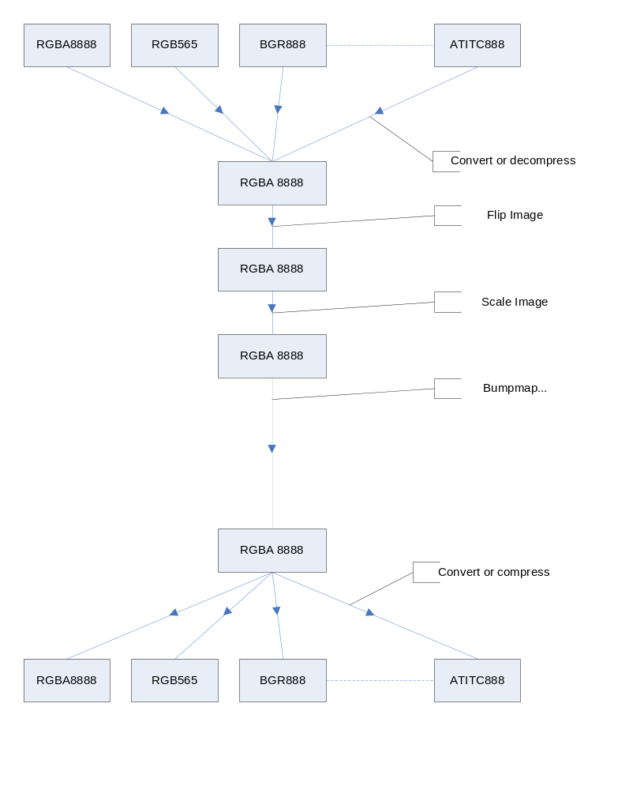

Extending the library with new basic formats

A basic format is a bit accurate type that fits in our 32bit RGBA8888 intermediate format. To extend the library with new basic formats all that needs to be done is add a conversion from the new format into the generic intermediate format and vice versa.

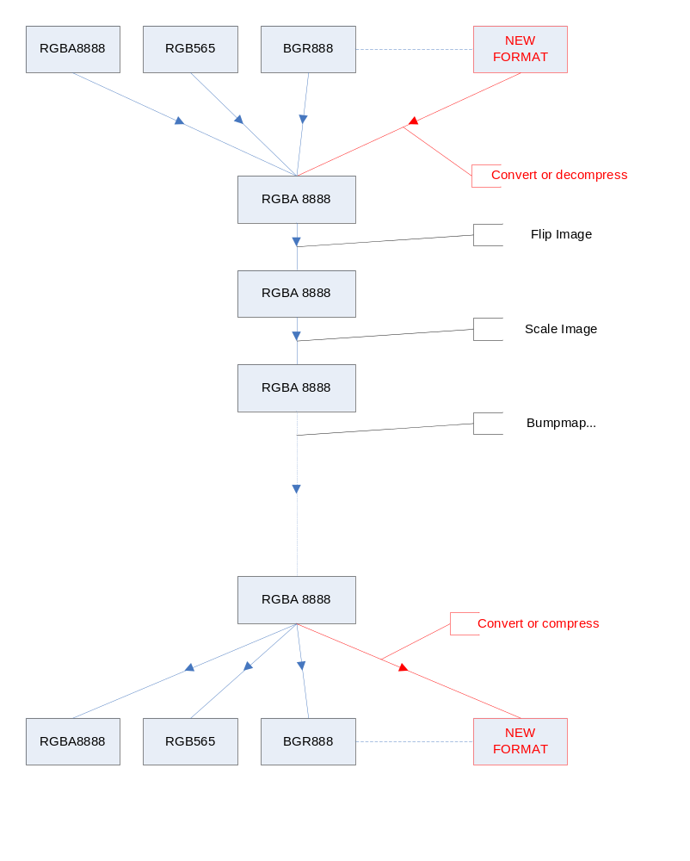

Extending the library with floating point formats

Floating point formats typically don’t fit in RGBA8888. Increasing the intermediate format to include floating point formats has unwanted side effects and complications. We recognize 3 scenario’s that need to be implemented to support floating point formats without a major rewrite of the pipeline.

Float input → Normal output

Convert to non float type early and follow the regular pipeline.
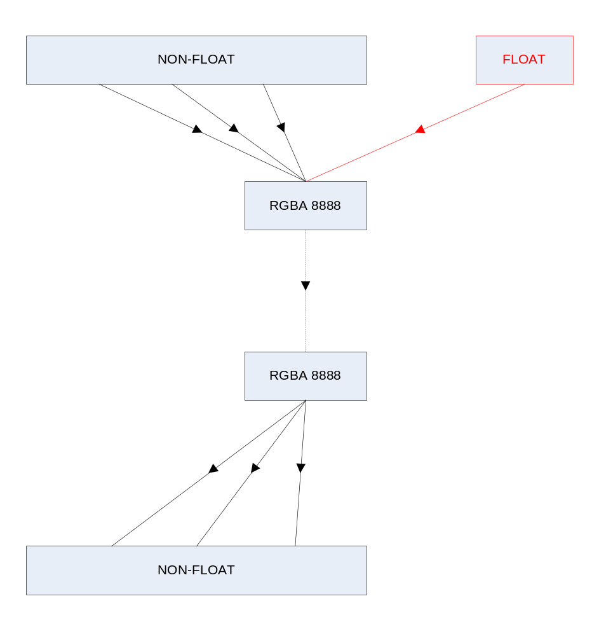

Normal input → Float output

Convert at the final stage.

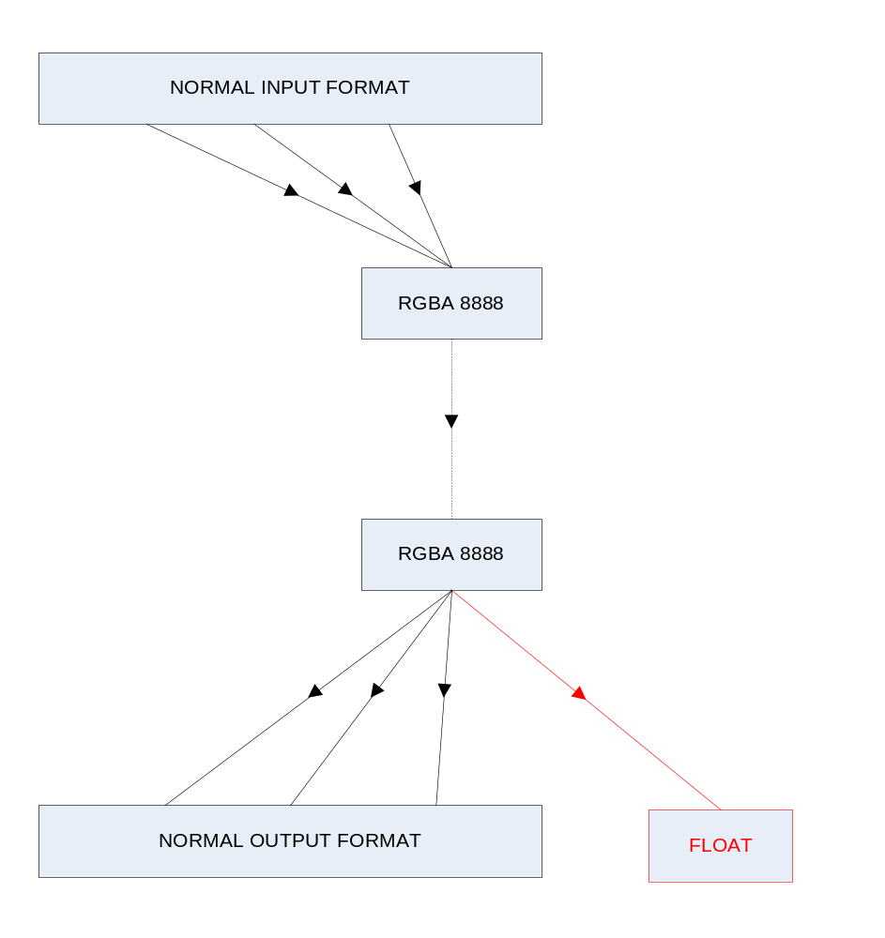

Float input → Float output

Create the pipeline for float only cases. Convert incoming type to RGBA_F (4x32bit IEEE FLOAT). Should be pretty trivial to add the computation steps like scale and float since all calculations are in full floating point without the need of complicated bit shifting steps.

